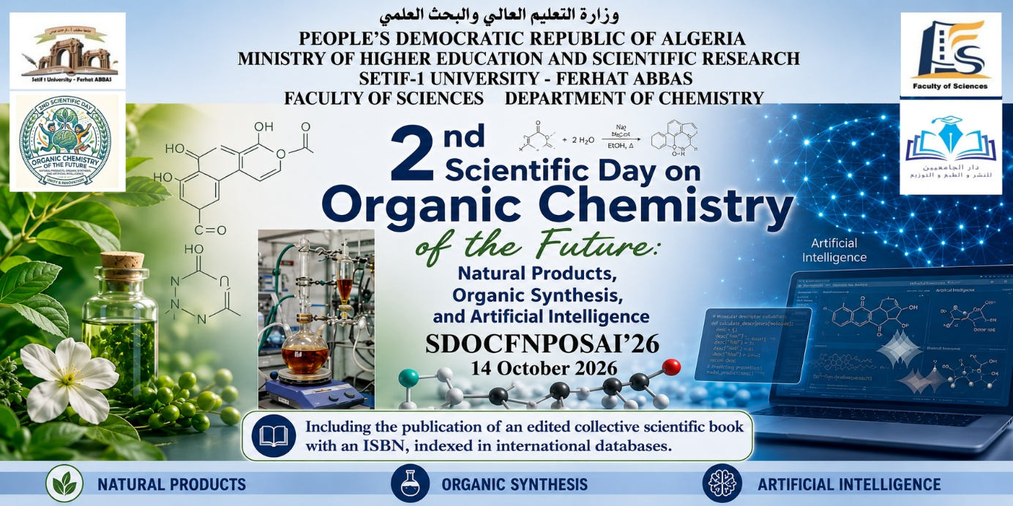

[Insert Full Title of the Chapter Here in Title Case]

First Author Name 1, Second Author Name 2∗, Third Author Name 1
1 Department of Chemistry, Faculty of Sciences, Ferhat Abbas Sétif-1 University, Sétif, Algeria
2 Laboratory of Electrochemistry of Molecular Materials and Complexes (L.E.M.M.C), Ferhat Abbas Sétif-1 University, Sétif, Algeria
* Corresponding Author Email: author.email@univ-setif.dz

Abstract / Résumé
Replace this text with your abstract (maximum 250 words). The abstract should provide a concise summary of the research background, key objectives, novel methodologies used (e.g., green extraction, microwave/ultrasound-assisted techniques, organic synthesis, computational/AI modeling), principal experimental results, and key conclusions.
Keywords: Keyword 1; Keyword 2; Keyword 3; Keyword 4; Keyword 5 (Provide 4 to 6 relevant keywords)

1. Introduction
Provide a comprehensive introduction to the research topic, highlighting the state-of-the-art literature, scientific contextualization, and problem statement. Emphasize the novel contribution of your work in fields such as green extraction techniques, organic synthesis, medicinal or industrial chemistry, and computational applications.
Clearly state the primary aims and specific objectives at the end of this section. Ensure that all standard bibliographic citations within the text strictly follow the APA 7th Edition style (e.g., Smith & Johnson, 2024; Ziani et al., 2025).
2. State of the Art and Recent Research / État de l'art et recherches récentes
Authors should provide a concise and critical review of the most recent and relevant scientific literature related to the topic, with particular emphasis on publications from the last 5 years whenever appropriate. This section should summarize current advances, compare existing approaches and methodologies, identify existing knowledge gaps or limitations, and clearly explain how the present work contributes to the advancement of the field. The literature review should be analytical rather than descriptive and supported by high-quality, peer-reviewed references

3. Materials and Methods
Describe experimental procedures, analytical techniques, chemical reagents, and instrumentation in sufficient detail to allow reproduction of the results. Organize this section using appropriate subheadings where necessary.

3.1 Reagents and Plant Materials
Specify the origin, botanical identification, pre-treatment steps, and grade/purity of all chemicals and biological materials utilized during experiments.

3.2 Extraction Procedures & Instrumentation
Detail operational parameters for processing (e.g., ultrasound power, microwave irradiation parameters, temperature, solvent ratios, extraction duration).

4. Results and Discussion
Present your experimental findings clearly and logically, accompanied by figures, tables, and chemical structures. Interpret results thoroughly in light of current scientific literature.

Parameter / Condition | Yield (%) | Bioactive Content (mg/g)
Method A (Conventional) | 12.4±0.5 | 45.2±1.1
Method B (Ultrasound-Assisted) | 18.7±0.3 | 68.4±0.8
Table 1. Experimental comparison of extraction techniques and yields.

5. Conclusion
Summarize the main outcomes of the chapter, highlighting key findings, practical applications in food/medicinal sciences, and potential avenues for future research.

Acknowledgements / Remerciements (Optional)
Acknowledge research grants, institutional support (e.g., L.E.M.M.C, Ferhat Abbas Sétif-1 University), or technical assistance received during the project.

Conflict of Interest Statement / Déclaration de conflit d'intérêts
The authors declare that they have no competing financial interests or personal relationships that could have appeared to influence the work reported in this paper.
Originality Statement / Déclaration d'originalité
The authors certify that this chapter is an original work, has not been published previously, is not under consideration elsewhere, and does not contain plagiarism. All sources have been appropriately cited.

References / Références
Please ensure all citations strictly adhere to APA 7th Edition format:
- Author, A. A., & Author, B. B. (2024). Title of the journal article. Title of Journal, 15(2), 123–135. [https://doi.org/xx.xxx/yyyy](https://doi.org/xx.xxx/yyyy)

Author Checklist & Technical Specifications
- Language: English / French
- Length: 10 – 20 pages
- Page Format: A4, 2.5 cm margins on all sides
- Typography: Times New Roman |
- Title: 16 pt Bold | Subheadings: 12–14 pt Bold |
- Body: 12 pt
- Line Spacing: 1.5 spacing
- Reference Style: APA 7th Edition

