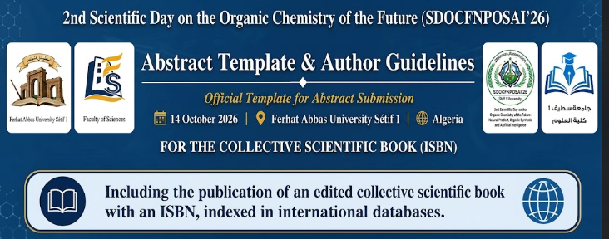
Abstract Title (Times New Roman, 14 pt, Bold, Centered)
First Author¹, Second Author², Third Author¹
¹ Department, Institution, City, Country
² Department, Institution, City, Country
Corresponding author: email@example.com
Conference Topic: (Please indicate the conference topic that best matches your submission: Natural Products, Organic Synthesis, Green Chemistry, or Artificial Intelligence).
Abstract
The abstract should be written as a single paragraph and should not exceed 250 words. It should provide a clear, concise, and informative summary of the research, including the purpose of the study, the methodology employed, the main findings, and the significance of the results. The abstract should be self-contained and should not include references, figures, tables, or unexplained abbreviations.
Formatting Requirements:
The abstract must be prepared in Times New Roman, 12-point font, with single-line spacing and justified text alignment. Abstracts may be submitted in English or French.
Keywords: Provide 4–6 relevant keywords that best describe the content of your abstract. Separate the keywords with semicolons.

